**Project Design Phase Solution Architecture**

|  |  |
| --- | --- |
| Date | 21/06/25 |
| Team ID | LTVIP2025TMID52137 |
| Project Name | Visualizing housing market trends: an analysis of sale prices and features |
| Maximum Marks | 4 Marks |

**Solution Architecture:**

Solution architecture is a complex process – with many sub-processes – that bridges the gap between business problems and technology solutions. Its goals are to:

* The architecture separates data preprocessing, storage, visualization, and UI layers—making it easy to maintain, scale, and enhance.
* Cleaned data from MySQL is visualized using Tableau dashboards, offering region-wise, year-wise, and seasonal insights with filtering capabilities.
* Dashboards are embedded into a Flask-based web interface, allowing end users to interact with visual data through a user-friendly portal.
* The solution supports future extensions like forecasting models and can be deployed locally or on cloud platforms like Heroku or AWS.

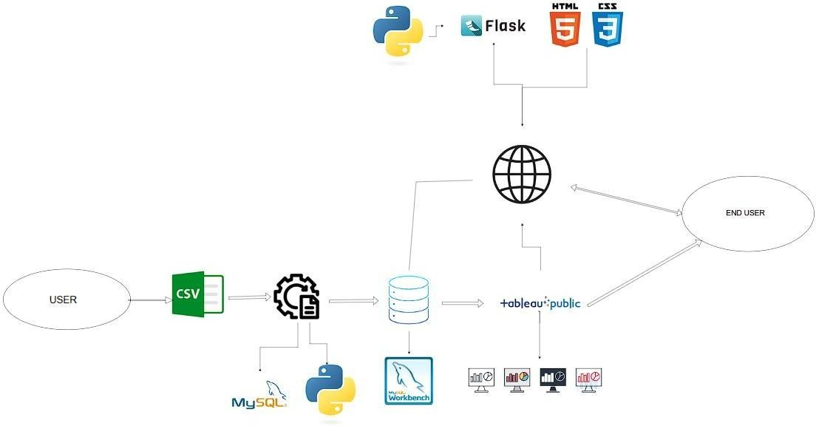**Solution Architecture Diagram:**